
Faculty of Computer Science and Engineering
Ghulam Ishaq Khan Institute of Engineering Sciences and Technology, Topi

CS112L Object-Oriented Programming Lab

P R O J E C T R E P O R T
Digital Vault
A C++ Digital Wallet — OOP Design & Implementation

Course | CS112L – OOP Lab
Marks | 10
Instructor | Sajid Ali
Date Submitted | 20/04/2026
Student 1 | Muhammad Ammar
Reg. No. 1 | 2025474
Student 2 | Misbah Alam
Reg. No. 2 | 2025411

Ghulam Ishaq Khan Institute — Topi, KPK, Pakistan

1. Introduction

Digital Vault is a C++17 digital wallet application that allows multiple users to register accounts, log in with a PIN, deposit and withdraw money, send funds to other users, and view a complete transaction history. The system is built entirely using standard C++17 and five custom header files (Transaction.h, Wallet.h, User.h, FileManager.h, VaultApp.h), together with the Crow header-only HTTP framework (crow_all.h) for serving an HTTP API. The front-end web interface (index.html / React) is outside the scope of this C++ report and is mentioned only where necessary to explain how the C++ server is invoked.

All core business logic — user management, wallet arithmetic, transaction recording, and file persistence — lives in the five custom C++ headers. This report analyses exclusively those C++ components and the object-oriented design principles they embody.

2. Motivation

Digital payment systems such as JazzCash and EasyPaisa have become central to everyday financial transactions in Pakistan. The motivation behind Digital Vault was to replicate the core mechanisms of such a system from scratch in C++, demonstrating that a fully functional multi-user digital wallet can be implemented using pure object-oriented design — without relying on a database engine or third-party business-logic library.

The project was also motivated by the academic goal of applying every major OOP concept taught in CS112 in a realistic, multi-class software system: classes and objects to model users, wallets, and transactions; inheritance so that VaultApp reuses FileManager persistence logic; encapsulation to protect balance and PIN data; and file I/O to achieve data persistence across server restarts.

3. Purpose and Objectives

- Allow multiple users to create secure wallet accounts identified by phone number and PIN.
- Maintain each wallet’s running balance and a full history of up to 100 transactions.
- Support deposits, withdrawals, and peer-to-peer money transfers between wallets.
- Persist user data and transaction history to plain-text files (users.txt, transactions.txt) so that data survives server restarts.
- Expose wallet operations over an HTTP API (via Crow) so that a web front-end can invoke them — note: the HTTP layer is not an OOP topic; it is a thin glue layer in main.cpp.
- Demonstrate all major C++ OOP concepts in a coherent, real-world codebase.

4. Problem Statement

The following concrete engineering challenges were addressed by the C++ design:

- Managing multiple user accounts in memory with O(n) lookup by phone number, without a database.
- Ensuring balance integrity: a withdrawal must atomically reduce the sender’s balance and a send must atomically update both sender and receiver balances, even if the operation fails partway.
- Recording every financial event as an immutable Transaction object so that a full audit trail is always available.
- Persisting all state to flat text files in a pipe-delimited format and correctly reconstructing the entire object graph on startup (loading users, then matching transactions to the correct Wallet by walletID).
- Keeping HTTP routing in main.cpp as thin glue, so that all business rules live in reusable C++ classes independent of the web framework.

5. Proposed Solution

The solution is a layered class hierarchy of five custom C++ header files. Each header owns a single responsibility and depends only on the headers below it in the dependency chain:

Transaction.h (no dependencies)
↑
Wallet.h (depends on Transaction.h)
↑
User.h (depends on Wallet.h)
↑
FileManager.h (depends on User.h)
↑
VaultApp.h (inherits FileManager, owns User* array)
↑
main.cpp (Crow HTTP routes — thin glue only)

5.1 Transaction.h
Represents a single immutable financial event. Stores type (DEPOSIT / WITHDRAW / SENT / RECEIVED), amount, balance after the transaction, a text description, and a timestamp string. Provides getters for all fields and a saveToFile() method that writes one pipe-delimited line to an open ofstream. No setters exist: a Transaction is constructed once and never mutated.

// Transaction.h — core fields
class Transaction {
private:
string type; // DEPOSIT | WITHDRAW | SENT | RECEIVED
double amount;
double balanceAfter;
string description;
string timestamp;
public:
Transaction(string t, double amt, double bal, string desc, string time);
void saveToFile(ofstream& file);
string getType(); double getAmount(); double getBalanceAfter();
string getDescription(); string getTimestamp();
};

5.2 Wallet.h
Manages a user’s running balance and owns an array of up to 100 Transaction pointers (Transaction* history[MAX_TX]). Provides deposit(), withdraw(), and sendMoney() methods that update the balance and call addTransaction() to record the event. Also provides loadTransaction() (used by FileManager on startup) and saveTransactions() (writes all history lines prefixed with walletID). The destructor deletes all Transaction objects, following RAII.

// Wallet.h — key members
class Wallet {
private:
double balance;
string walletID;
void addTransaction(string type, double amount, string desc, string time);
public:
static const int MAX_TX = 100;
Transaction* history[MAX_TX];
int transactionCount;

Wallet(string id, double bal);
~Wallet(); // deletes all Transaction*
void deposit(double, string, string);
bool withdraw(double, string, string);
bool sendMoney(Wallet& receiver, double amount, string time);
void loadTransaction(string, double, double, string, string);
void saveTransactions(ofstream&);
double getBalance(); string getWalletID(); int getTransactionCount();
};

5.3 User.h
Represents an account holder. Stores name, phone, CNIC, PIN (all as std::string) and holds a Wallet pointer (composition). The constructor performs member-wise initialisation. verifyPIN() provides the only way to check a PIN, keeping the raw string private in effect (though declared public for FileManager access — a noted area for future encapsulation). The destructor is declared but does not delete the Wallet pointer; lifetime management is handled by VaultApp.

// User.h — key members
class User {
public:
string name, phone, cnic, pin;
Wallet* wallet; // composition: User HAS-A Wallet

User(string n, string ph, string id, string p, Wallet* w);
~User();
bool verifyPIN(string entered); // returns entered == pin
};

5.4 FileManager.h
Handles all file I/O for the system. Stores the paths to users.txt and transactions.txt. saveUsers() iterates the User* array and writes each user as one pipe-delimited line. saveTransactions() delegates to each Wallet’s saveTransactions(). loadUsers() reads users.txt line by line, reconstructs Wallet and User objects with new, and returns the count. loadTransactions() reads transactions.txt and matches each record to the correct Wallet by walletID using a linear search.

// FileManager.h — responsibilities
class FileManager {
private:
string usersFile; // path to users.txt
string transactionsFile; // path to transactions.txt
public:
FileManager();
FileManager(string uf, string tf);
void saveUsers(User* users[], int count);
void saveTransactions(User* users[], int count);
int loadUsers(User* users[], int maxUsers); // returns count loaded
void loadTransactions(User* users[], int userCount);
};

5.5 VaultApp.h
The top-level application class. It inherits FileManager (IS-A relationship) to directly call loadUsers() and loadTransactions() in its constructor, and holds a private array User* users[MAX_USERS] together with a userCount integer. A private findUser(phone) helper performs linear search. All public methods (registerUser, verifyLogin, deposit, withdraw, sendMoney, getStatement) form the complete business API called by main.cpp route handlers. A nested struct ProfileInfo acts as a plain data transfer object for profile reads.

// VaultApp.h — structure
class VaultApp : public FileManager {
private:
static const int MAX_USERS = 20;
User* users[MAX_USERS];
int userCount;
User* loggedIn;
FileManager fileManager;
User* findUser(string phone);
string getTime();
void saveAll();
public:
struct ProfileInfo { string name,phone,cnic,walletID; double balance; };

VaultApp(); // loads users + transactions on startup
string registerUser(string name, string phone, string cnic,
string pin, double initial);
bool verifyLogin(string phone, string pin);
string getUserName(string phone);
ProfileInfo getProfile(string phone);
double getBalance(string phone);
string deposit(string phone, double amount);
string withdraw(string phone, double amount);
string sendMoney(string from, string to, double amount);
vector<Transaction*> getStatement(string phone);
};

6. OOP Concepts Used

Every OOP concept below is traced to an exact class and header file in the actual project source.

OOP Concept | Header File / Location | How It Is Applied
Classes & Objects | All five .h files | Transaction, Wallet, User, FileManager, VaultApp are each a class. Objects like new Wallet(walletID,0) and new User(name,phone,cnic,pin,w) are created in VaultApp::registerUser() and FileManager::loadUsers().
Encapsulation | Transaction.h Wallet.h | Transaction stores type, amount, balanceAfter, description, timestamp as private members; only getters are public. Wallet keeps balance and walletID private; balance changes only through deposit(), withdraw(), sendMoney() which also record a Transaction, preventing silent modifications.
Inheritance | VaultApp.h→FileManager.h | VaultApp : public FileManager gives VaultApp direct access to loadUsers() and loadTransactions() without delegation. The constructor calls them immediately to restore state. This is the project’s single IS-A relationship.
Composition (HAS-A) | User.h (Wallet*) Wallet.h (Transaction*[]) | User HAS-A Wallet via pointer member wallet. Wallet HAS-A array of Transaction pointers history[MAX_TX]. Both relationships model real-world ownership: a user owns one wallet; a wallet owns its history.
Constructor Overloading | FileManager.h | FileManager provides two constructors: a default no-arg constructor FileManager() and a parameterised one FileManager(string uf, string tf). VaultApp uses the parameterised version to set file paths at startup.
Destructor / RAII | Wallet.h | Wallet::~Wallet() iterates history[] and calls delete history[i] for each non-null pointer, preventing memory leaks when a Wallet object goes out of scope. This is the RAII pattern applied to raw pointer ownership.
Member Functions & Getters | Transaction.h Wallet.h User.h | Transaction exposes getType(), getAmount(), getBalanceAfter(), getDescription(), getTimestamp(). Wallet exposes getBalance(), getWalletID(), getTransactionCount(), getTransaction(int). All are defined inline in the header.
Nested Struct (User-defined Type) | VaultApp.h | ProfileInfo is a public nested struct inside VaultApp. It bundles name, phone, cnic, walletID, and balance into one return value for getProfile(), avoiding a raw tuple or multiple out-parameters.
Static Constant | Wallet.h VaultApp.h | Wallet::MAX_TX = 100 and VaultApp::MAX_USERS = 20 are declared static const int. They define compile-time array bounds shared across all instances without consuming per-object memory.
File I/O | FileManager.h Transaction.h | FileManager uses std::ofstream and std::ifstream with getline() and stringstream to implement pipe-delimited serialisation and deserialisation. Transaction::saveToFile(ofstream&) writes its own record line, following the single-responsibility principle.
STL Usage | VaultApp.h main.cpp | std::vector<Transaction*> is the return type of getStatement(). std::string is used throughout as the primary text type. std::to_string() generates walletIDs. These are standard library tools used as part of the C++ OOP ecosystem.

7. Architecture and Flow Diagram

7.1 Class Dependency and Ownership
The diagram below shows the five C++ header files, their inheritance relationship, their composition links, and the thin Crow HTTP glue in main.cpp. Only C++ constructs are shown; the front-end is deliberately excluded.

main.cpp (Crow HTTP routes)
|
calls methods on
|
v
+----------------------------------------------------------+
| VaultApp.h |
| inherits FileManager owns: User* users[20] |
| findUser() registerUser() verifyLogin() |
| deposit() withdraw() sendMoney() |
| getStatement() getProfile() getBalance() |
+----------+----------------------------------+------------+
| IS-A (public inheritance) |
v | HAS-A (composition)
+-------------------+ v
| FileManager.h | +-----------+----------+
| saveUsers() | | User.h |
| saveTransactions | | name phone cnic |
| loadUsers() | | pin wallet* |
| loadTransactions | | verifyPIN() |
+-------------------+ +-----------+----------+
reads/writes: | HAS-A
users.txt v
transactions.txt +----------------+-----------+
| Wallet.h |
| balance walletID |
| history[100]: Txn* |
| deposit() withdraw() |
| sendMoney() |
| saveTransactions() |
+----------------+-----------+
| HAS-A (array)
v
+--------------+------------+
| Transaction.h |
| type amount |
| balanceAfter desc |
| timestamp |
| saveToFile() getters() |
+---------------------------+

7.2 Sequence: User Registration
The steps below trace a registerUser() call through the C++ class layers:

- main.cpp route handler reads name, phone, cnic, pin, initialDeposit from the HTTP JSON body.
- app.registerUser() is called on the VaultApp instance.
- VaultApp::findUser(phone) scans users[] to check for duplicate phone numbers.
- A walletID string is generated: "W-" + phone.substr(0,4) + "-" + to_string(userCount+1).
- new Wallet(walletID, 0) allocates a Wallet on the heap.
- new User(name, phone, cnic, pin, w) allocates a User on the heap, holding the Wallet pointer.
- The User pointer is stored in users[userCount++].
- w->deposit(initialDeposit, "Initial deposit", getTime()) records the first Transaction in the Wallet.
- saveAll() calls fileManager.saveUsers() and fileManager.saveTransactions(), writing to disk.
- An empty string (success) is returned to main.cpp, which sends HTTP 200.

7.3 Sequence: Money Transfer (sendMoney)
A peer-to-peer transfer passes through four classes:

- VaultApp::sendMoney(fromPhone, toPhone, amount) finds both User objects via findUser().
- Balance and amount validity checks are performed on from->wallet->getBalance().
- from->wallet->sendMoney(*(to->wallet), amount, time) is called.
- Inside Wallet::sendMoney(): sender balance -= amount; addTransaction("SENT", ...).
- receiver.balance += amount; receiver.addTransaction("RECEIVED", ...).
- Each addTransaction() call creates a new Transaction object via new Transaction(...).
- Control returns to VaultApp; saveAll() persists both wallets to disk.

7.4 Sequence: Server Startup (Data Loading)
On construction, VaultApp restores the full object graph from disk:

- VaultApp() constructor calls inherited loadUsers(users, MAX_USERS) from FileManager.
- loadUsers() opens users.txt, reads each pipe-delimited line with getline + stringstream.
- For each line: new Wallet(walletID, balance) and new User(name, phone, cnic, pin, w) are created; pointer stored in users[count++].
- loadTransactions(users, userCount) opens transactions.txt; for each line it extracts walletID and linearly searches users[] to find the matching Wallet.
- Wallet::loadTransaction() appends a new Transaction to that Wallet’s history[].
- Server begins listening; all in-memory state matches the last saved state.

8. Screenshots

The following screenshots demonstrate the working features of Digital Vault accessed through the HTTP API and web interface. Insert actual screenshots in the placeholder frames below.

8.1 User Registration

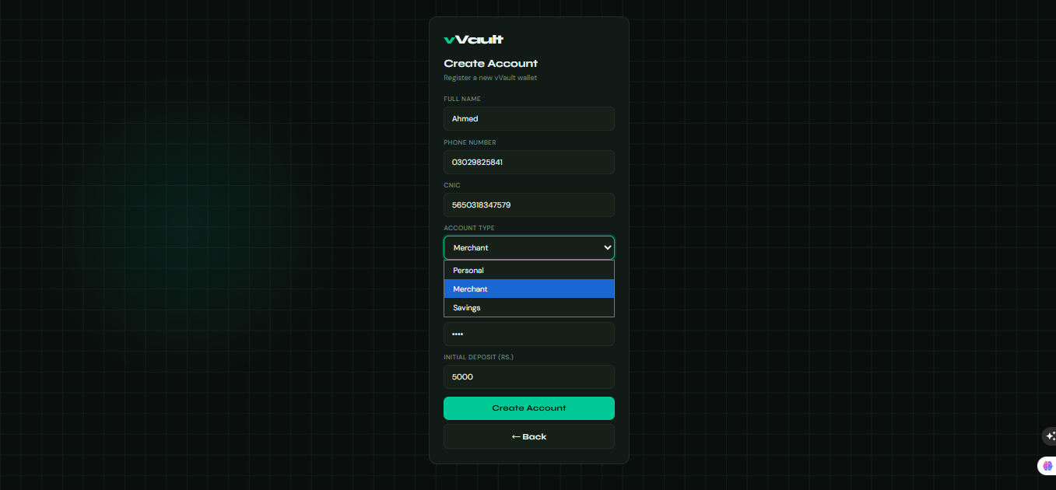

8.2 User Login and Wallet Dashboard

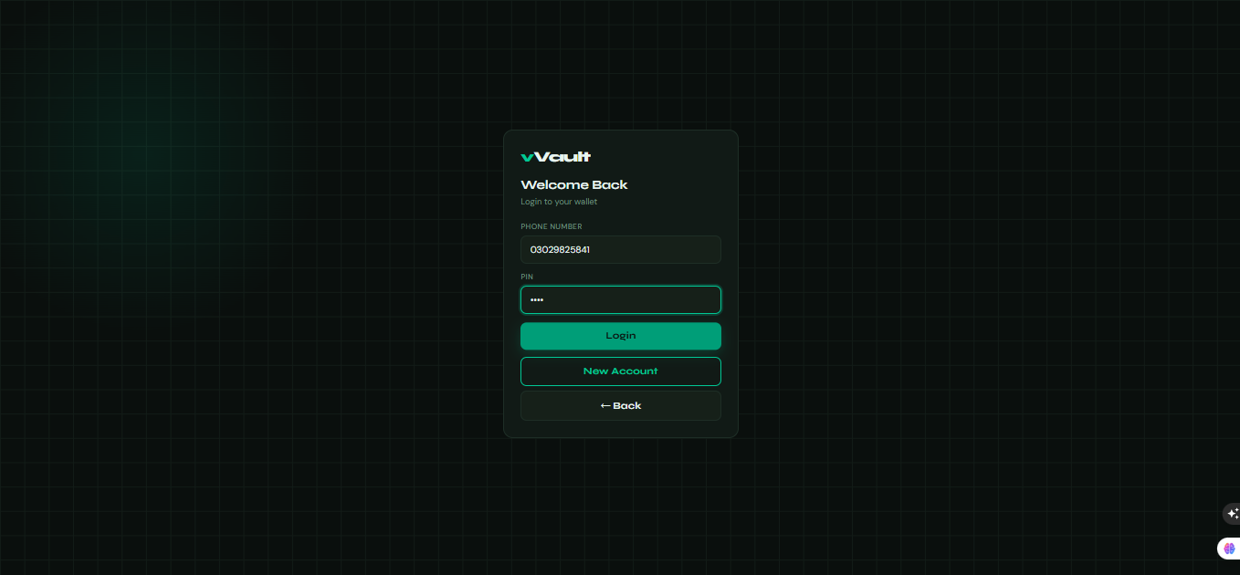

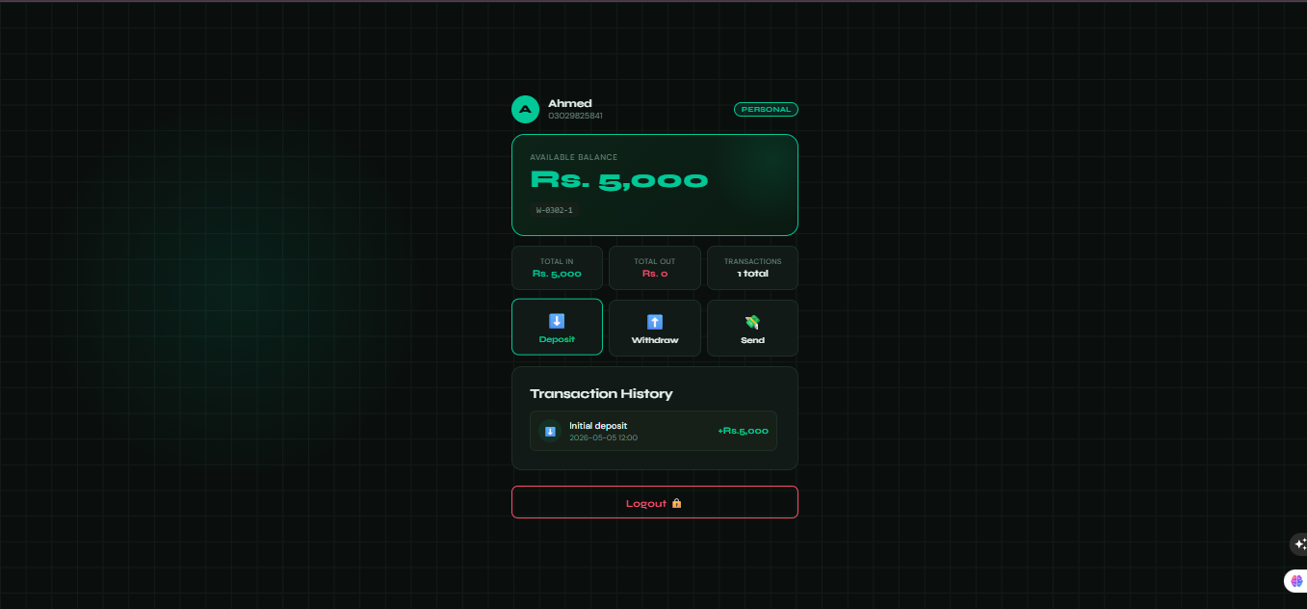

8.3 Deposit Operation
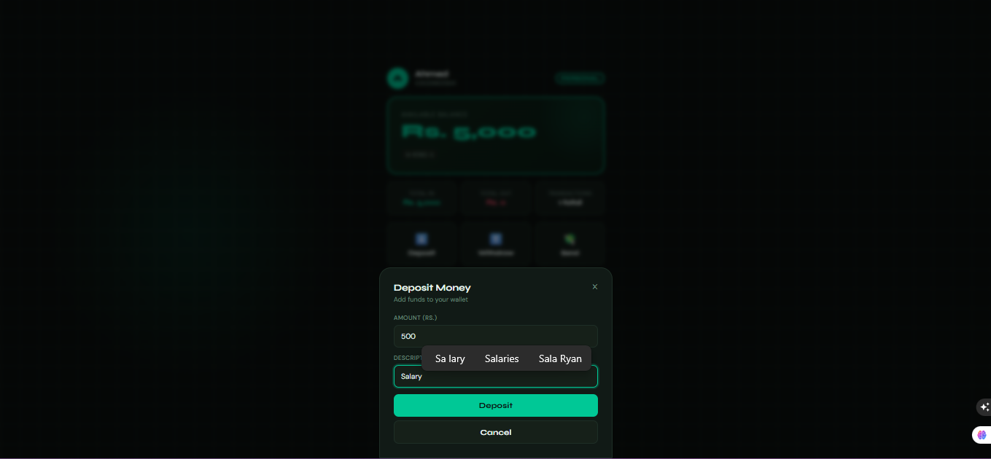

8.4 Money Transfer Between Wallets

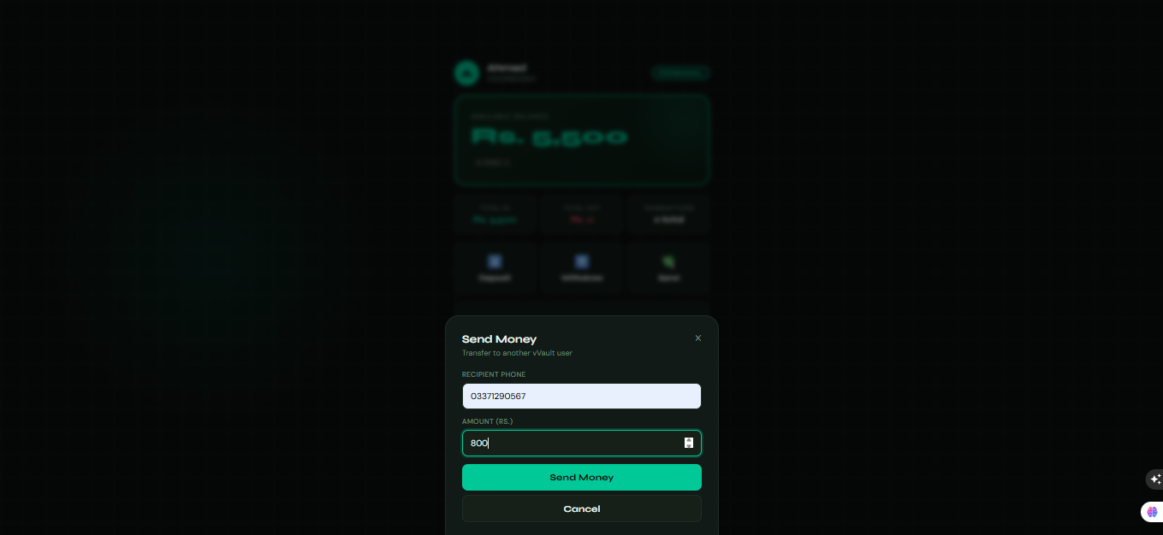

8.5 Transaction Statement

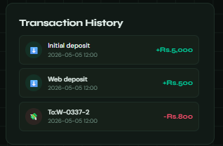

9. Conclusion

Digital Vault successfully demonstrates the application of core C++ object-oriented programming principles within a realistic, multi-user financial system. Through the five custom header files, the following outcomes were achieved:

- Classes and objects cleanly model real-world entities: each Transaction is immutable, each Wallet owns its history, each User owns a Wallet, and VaultApp coordinates the whole system.
- Encapsulation protects balance integrity: no code outside Wallet can change a balance without simultaneously recording a Transaction.
- Inheritance eliminates duplication: VaultApp reuses FileManager’s I/O methods directly through the IS-A relationship instead of duplicating file-handling code.
- Constructors and destructors enforce proper object initialisation and memory cleanup (RAII in Wallet::~Wallet).
- File I/O with std::fstream provides durable persistence without a database engine, keeping the system dependency-free for core logic.
- A nested struct (ProfileInfo) serves as a clean data-transfer object, avoiding raw tuples or complex return types.

Possible future improvements include making all User members properly private with accessor methods, replacing raw pointer arrays with std::vector<std::unique_ptr<User>>, adding SHA-256 PIN hashing via OpenSSL (already linked in CMakeLists.txt), and introducing a proper session token system. However, the current implementation fully meets the CS112L project objectives and clearly illustrates how OOP design produces a well-structured, maintainable C++ codebase.

References

- Stroustrup, B. (2013). The C++ Programming Language, 4th Edition. Addison-Wesley.
- Lippman, S. B., Lajoie, J., Moo, B. E. (2013). C++ Primer, 5th Edition. Addison-Wesley.
- Crow C++ Micro Web Framework — header-only HTTP server. https://crowcpp.org/
- cppreference.com — std::fstream, std::stringstream, std::vector. https://en.cppreference.com/
- CS112 — Object-Oriented Programming Course Notes, GIKI, 2025-26.

